QS WORLD RANKING

INTRODUCTION
The QS World University Rankings provide a comprehensive annual evaluation of higher education institutions worldwide, assessing over 1,500 universities based on academic reputation, employer reputation, faculty/student ratio, citations, international faculty, and international student ratios. Exploratory Data Analysis (EDA) on this dataset typically involves cleaning, analyzing correlations between metrics, and visualizing trends in university performance across different countries and years to derive insights into global higher education

▪ Importing data and Exporting data
▪ Data cleaning
▪ Data transformation
▪Descriptive statistics
▪Normalization and Minmaxmix
▪Basic visualization
▪ Advanced visualization
▪ Interactive visualization
▪Kmeans clustering
▪ Probability analysis
▪ Summary & insights

Importing data and Exporting data
The QS World University Rankings dataset provides a comprehensive look at global higher education, ranking over 1,500 institutions based on factors like academic reputation, employer reputation, faculty-student ratio, and research citations. To identify top-performing universities, analyze trends over time and evaluate regional differences. 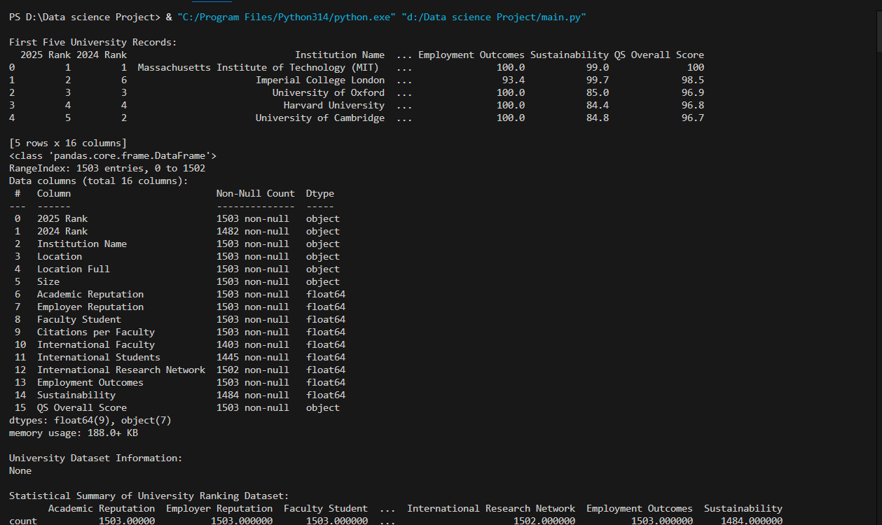

Data cleaning
This guide provides an overview of performing Exploratory Data Analysis and Data Cleaning on the QS World University Rankings dataset, commonly sourced from platforms. The QS World University Rankings, is an annual publication evaluating university performance based on factors like academic reputation, employer reputation, research impact, and internationalization. 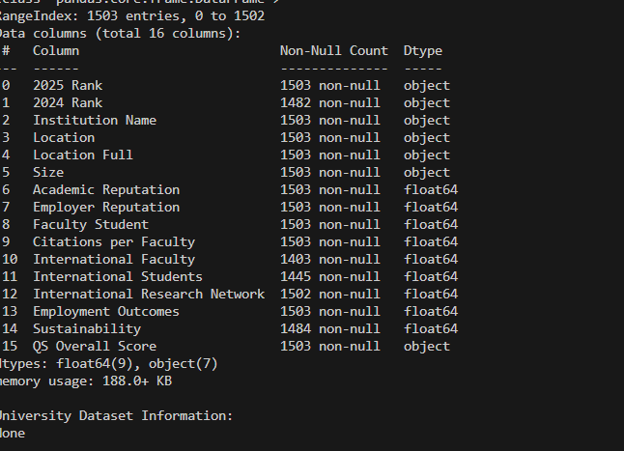

▪Statistics
Based on the provided search results, here is an analysis of QS World Rankings, and introductory statistics in the context of Data Science.The QS World University Rankings by Subject 2025 highlights the top institutions for Data Science, Artificial Intelligence, and Statistics & Operational Research.
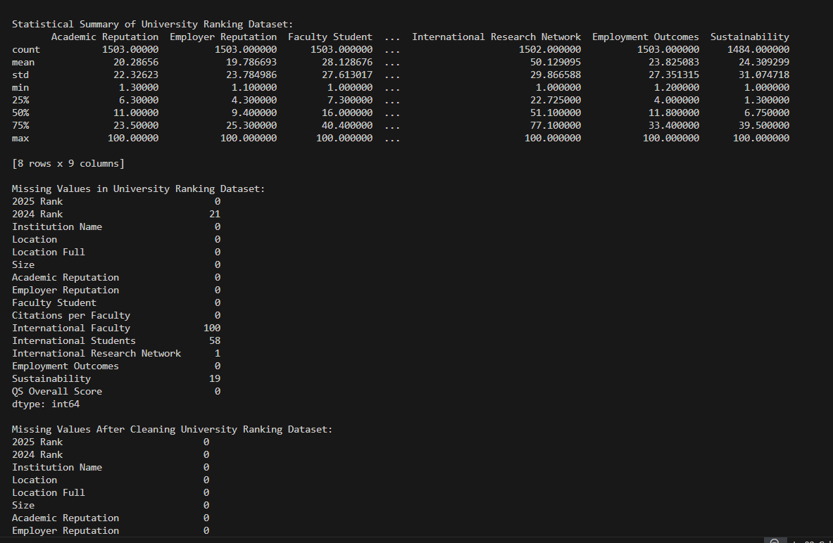

▪ Normalisation and MinmaxScaler
QS World University Rankings evaluate nearly 1,500 institutions using metrics like academic reputation, citations, and faculty-student ratios to measure academic prestige and performance. To analyze this data, normalization techniques like MinMaxScaler are used to scale different metrics into a uniform 0-1 range, ensuring all features contribute equally. These rankings compare universities based on diverse criteria, including academic reputation, employer reputation, and research activity. They are crucial for assessing international research output and educational quality.Data in the QS dataset often has varying magnitudes Normalization is required to prevent features with larger raw values from dominating machine learning model predictions .

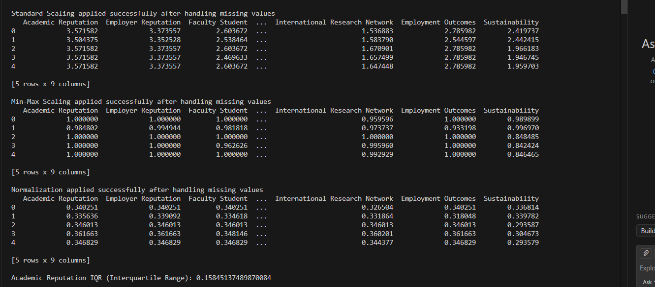

▪Descriptive statistics
The QS World University Rankings, published annually by Quacquarelli Symonds (QS), is one of the most widely read university rankings in the world, providing comprehensive evaluations of higher education institutions based on key performance metrics.
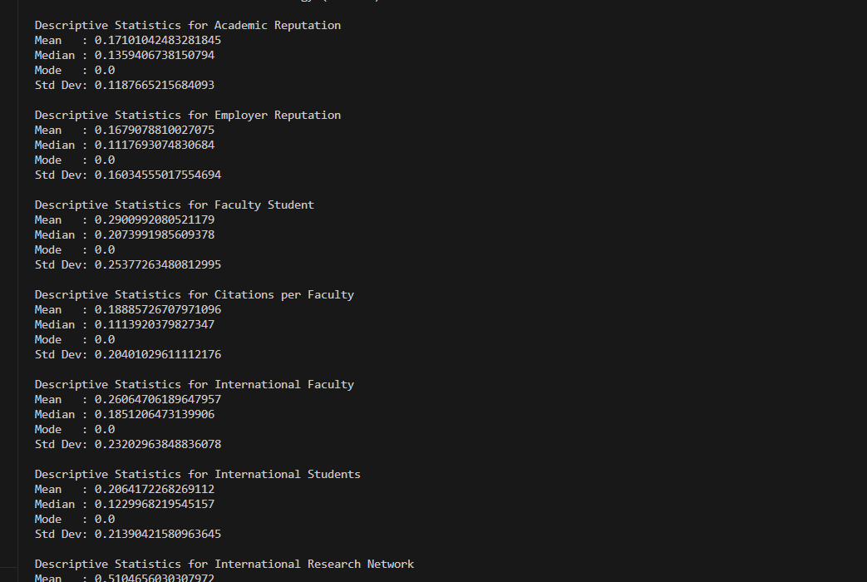

▪Basic visualization
The QS World University Rankings, published annually by Quacquarelli Symonds (QS), is a comprehensive system for evaluating the top-performing higher education institutions worldwide. Established in , it is considered one of the three most influential, alongside Times Higher Education (THE) and the Academic Ranking of World Universities (ARWU).
▪Line plot
The QS World University Rankings, published annually by Quacquarelli Symonds (QS), is a comprehensive, widely recognized evaluation of over 1,500 global institutions. It assesses universities based on criteria such as academic and employer reputation, research impact, and internationalization, making it a key tool for students and academics. Recent editions have emphasized sustainability and employability in their methodology.
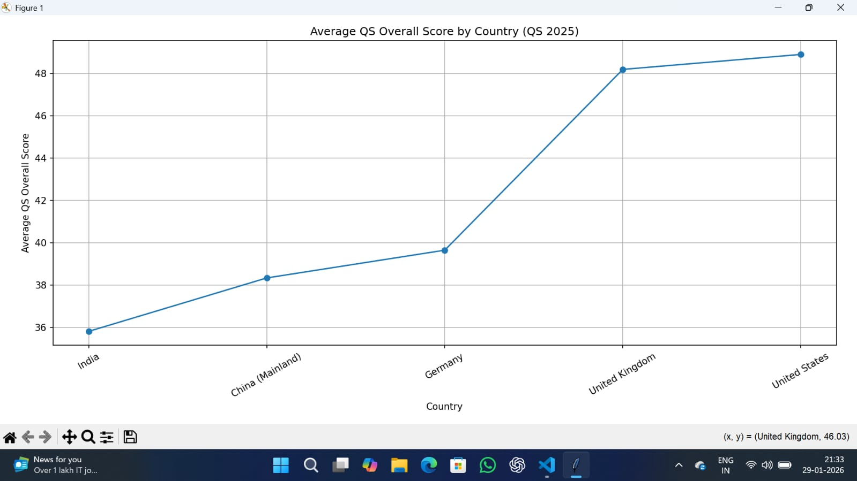

▪Barplot
The QS World University Rankings, published annually by Quacquarelli Symonds (QS), is one of the most widely read and influential global university rankings. It evaluates institutions based on a combination of academic reputation, employer reputation, research impact, and internationalization.
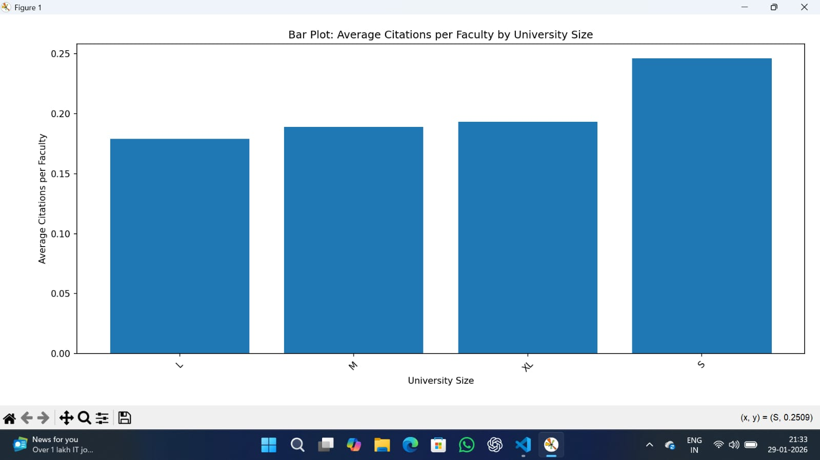

▪Histogram
The QS World University Rankings, launched in by Quacquarelli Symonds, is an annual publication that evaluates the top higher education institutions globally. The edition features over universities across locations. The rankings are widely used by students, employers, and policymakers, aiming to provide a comprehensive, data-driven assessment of university performance.
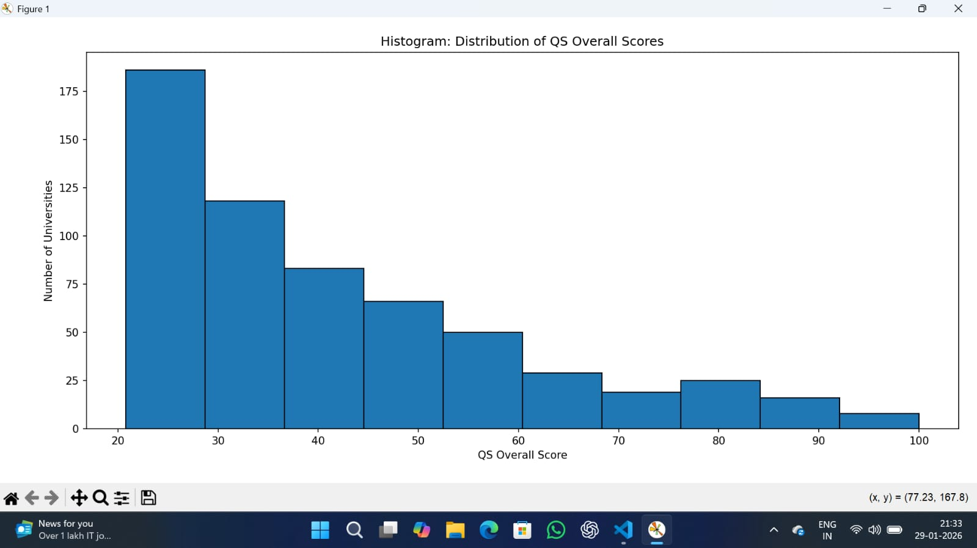

▪ Advanced visualization
The search results provided information regarding QS World University Rankings, including top-ranked institutions and specific data analysis, rather than a single "Advanced Visualization" tool.
▪pair plot
Advanced visualization techniques, specifically pair plots (pairplots) using libraries like Seaborn, are used to analyze the complex relationships between the different metrics that determine the QS World University Rankings. These plots allow for the exploration of correlations, trends, and outliers across metrics such as Academic Reputation, Employer Reputation, Citations per Faculty, and Faculty/Student Ratio.
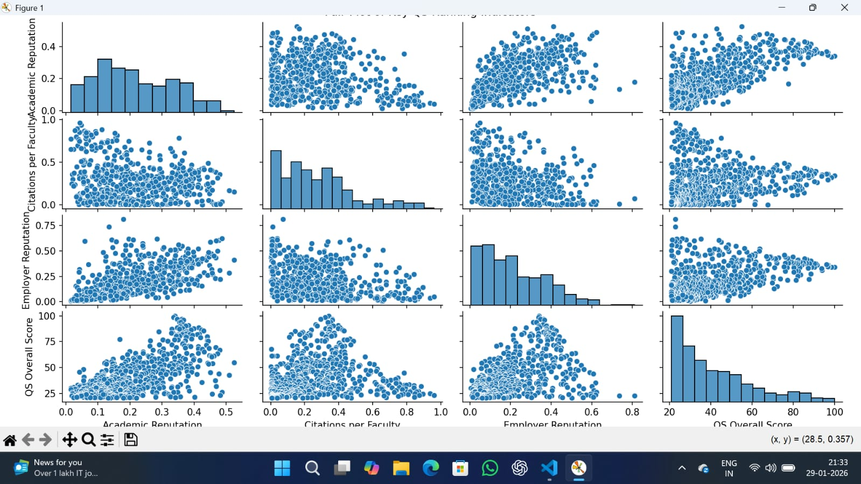
▪Heatmaps
Advanced visualizations of QS World University Rankings, including heatmaps, have been developed using datasets covering offering insights into university performance, missing data, and geographical distribution. Python packages like missing no have been utilized to create heatmaps that measure the correlation between missing values in the dataset, such as missing scores or student-faculty ratios, to understand data quality across the ranked universities.
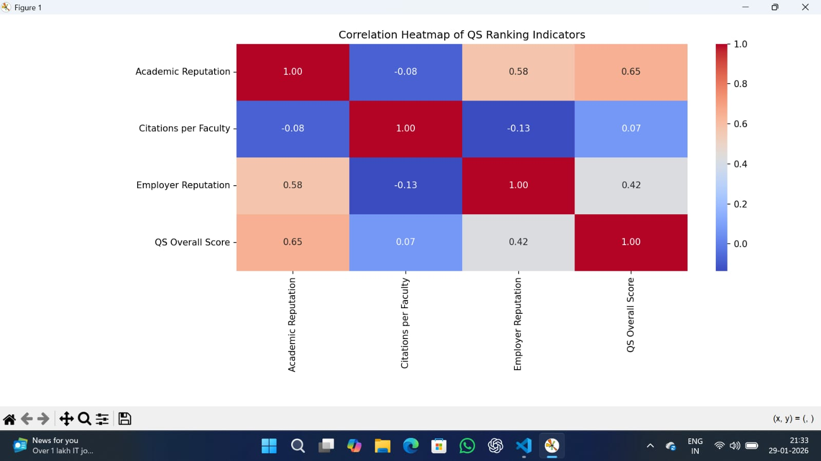
▪Covariance Heatmap
Advanced visualizations of the QS World University Rankings, including covariance/correlation heatmaps, are utilized to analyze the relationships between different metrics (e.g., Academic Reputation, Citations per Faculty) and overall performance. These visualizations help identify which factors most strongly drive ranking improvements, such as the correlation between research citations and overall scores.
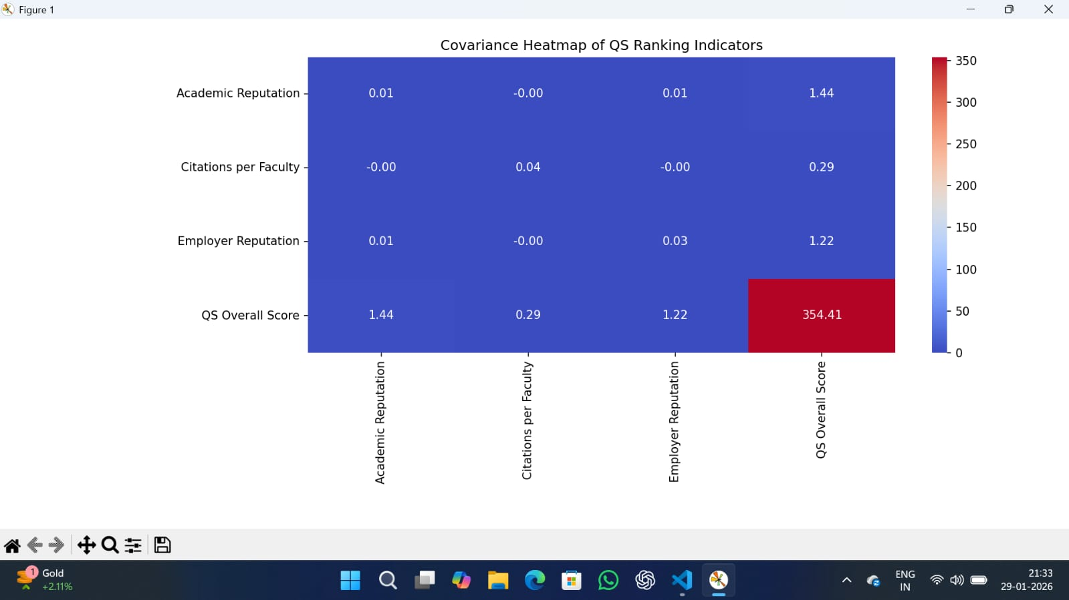

▪Interactive visualisation
Creating an interactive visualization of the QS World University Rankings using Python's Plotly and Plotly Dash allows for dynamic exploration of university data, including rankings, scores, and geographic distribution. Plotly Express is used to generate the charts, while Dash provides the web application framework to add interactive components like dropdowns and filters.

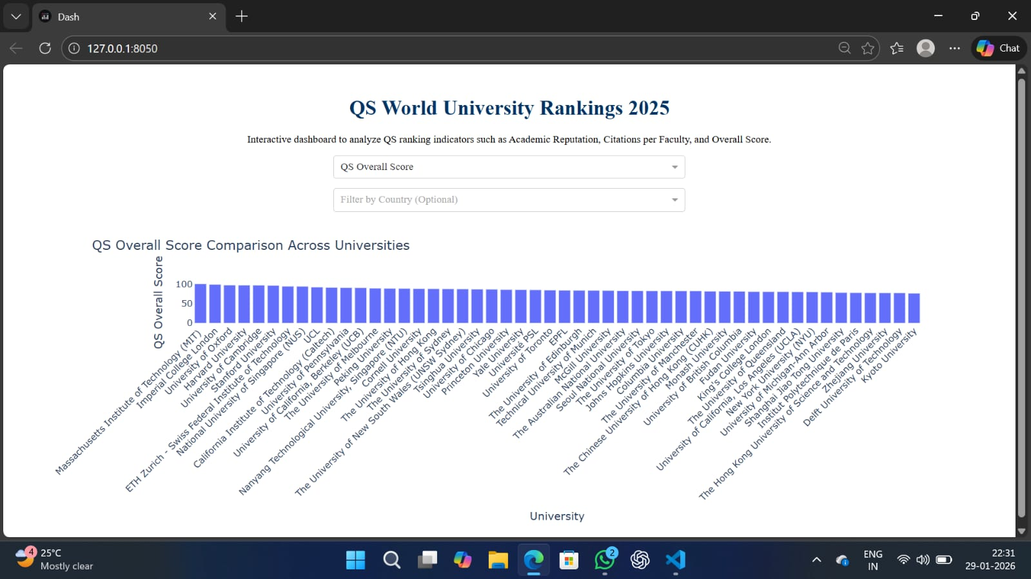

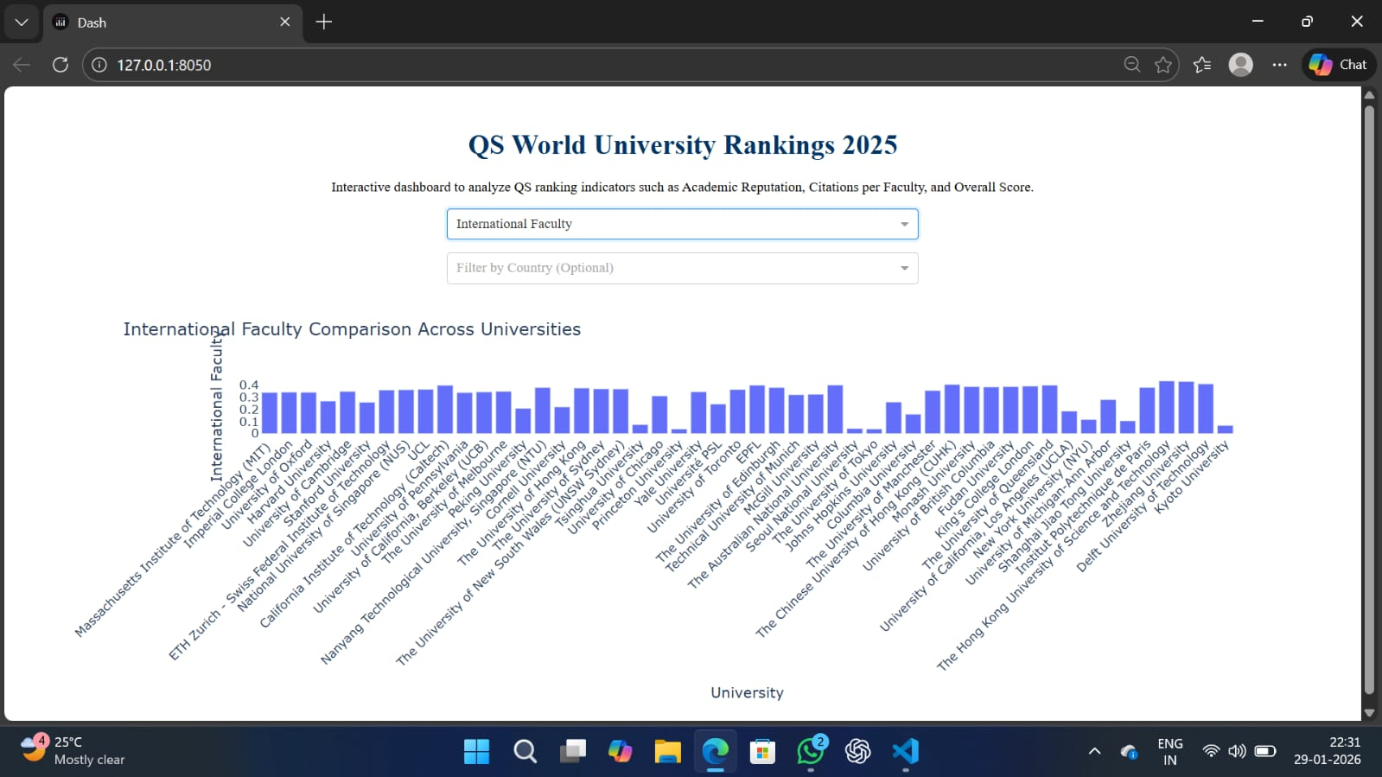

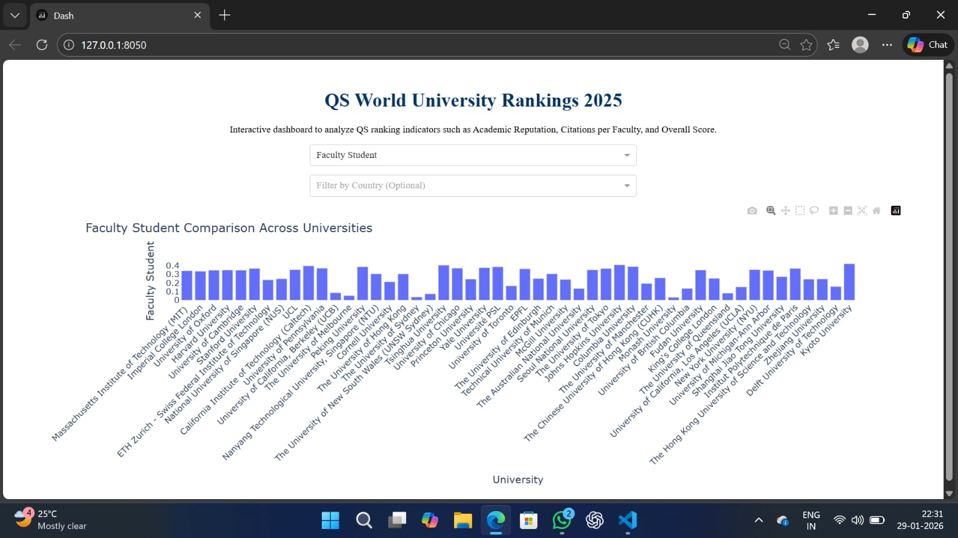

▪ Probability analysis
The QS World University Rankings (WUR) evaluate institutions based on a weighted formula focusing on academic reputation, employer reputation, research impact, and internationalization. Probability analysis in this context often involves analyzing which institutions are likely to move up or down based on these metrics.
▪Kmeans clustering
K-means clustering is an unsupervised machine learning technique used to partition a dataset into K distinct, non-overlapping clusters based on feature similarities. In the context of QS World University Rankings, this method is applied to segment large numbers of universities into groups with similar profiles based on metrics like academic reputation, citations, and sustainability, rather than relying solely on a linear, ordinal ranking.
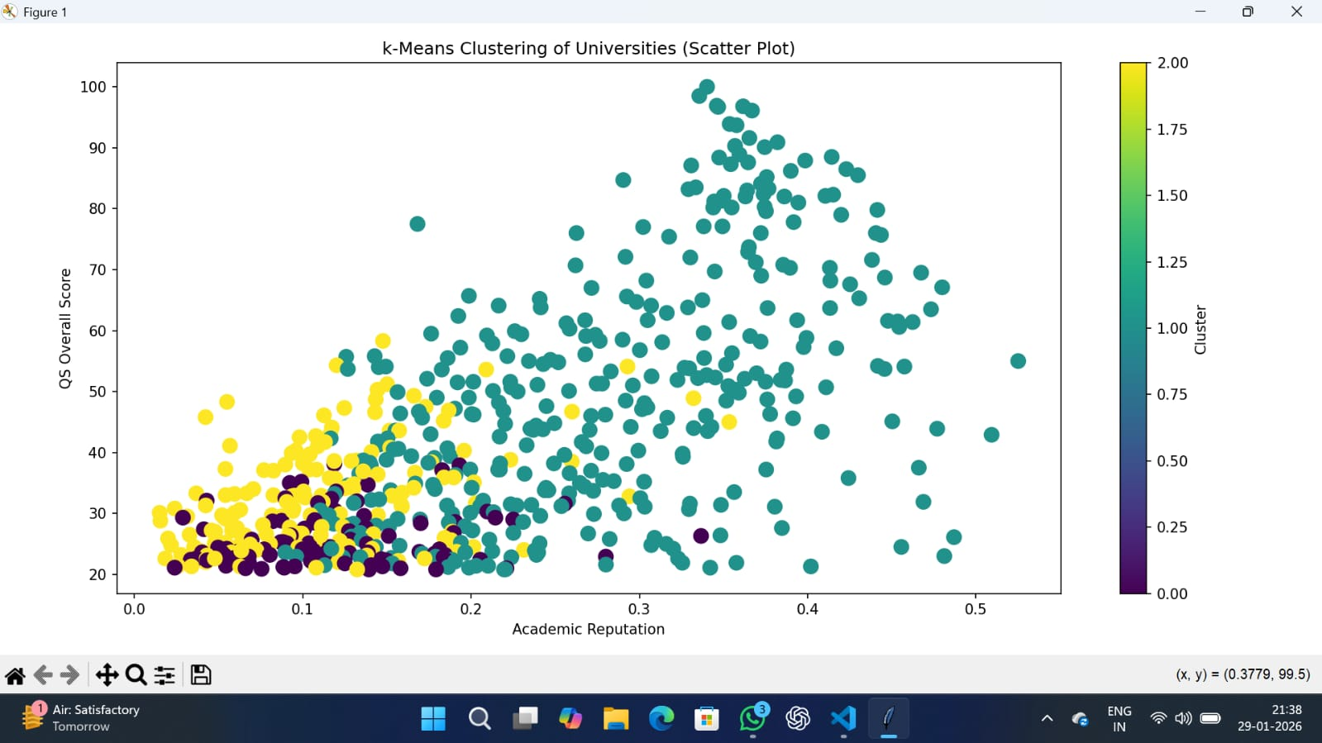

▪ Summary & insights
The project focuses on QS World University Rankings , released in mid, evaluated over institutions across locations, maintaining the Massachusetts Institute of Technology (MIT) as the world’s top-ranked university for the fourteenth consecutive year. The edition highlights a highly competitive, globalized higher education landscape with significant representation gains from Asia and a rise in sustainability-focused metrics.

